Practical : 3

## Aim: Develop simple web page using built in Objects.

First.aspx

<%@ Page Language="vb" AutoEventWireup="false" CodeBehind="First.aspx.vb" Inherits="Practical_3.First" %>

<!DOCTYPE html>

<html xmlns="http://www.w3.org/1999/xhtml">

<head runat="server">

<title></title>

</head>

<body>

<form id="form1" runat="server">

<div>

</div>

</form>

</body>

</html>

First.aspx.vb

Public Class First

Inherits System.Web.UI.Page

Protected Sub Page_Load(ByVal sender As Object, ByVal e As System.EventArgs) Handles Me.Load

Response.Write("<br />Server Mappath : " & Server.MapPath("\"))

Response.Write("<br />Server Machine Name : " & Server.MachineName)

Response.Write("<br />Server Script Time Out : " & Server.ScriptTimeout)

Response.Write("<br />Trace Enabled? : " & Trace.IsEnabled)

Response.Write("<br />Trace Mode : " & Trace.TraceMode)

Response.Write("<br />Client Certificate : " & Request.ClientCertificate.ToString)

Response.Write("<br />Request HTTP Method : " & Request.HttpMethod)

End Sub

End Class

Output :

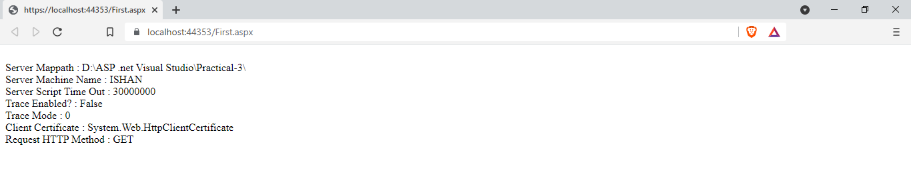

|  |  |  |  |
| --- | --- | --- | --- |
| Start Date | End/Sign Date | Faculty Sign | Remarks/Grade |
|  |  |  |  |